## Deck Budget

Select the “Deck Budget” sheet

* Add a title, bold it, underline it, change size to 16 point
* Resize the columns and right justify the Qty, Unit Price, and Total headers
* Add a formula at the end of each line equal to quantity times price
* Add a sub total at the bottom of the totals
* Calculate the tax equal to the sub total times the tax rate
* Calculate a grand total
* Format the Unit Price and Total to have two decimal places
* Format the tax rate as a percentage
* Put in select bottom borders

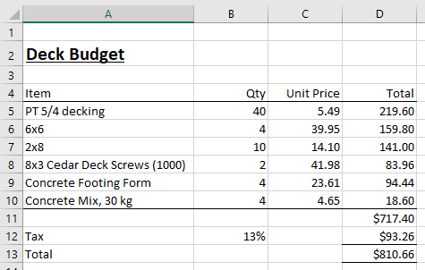

## Report Card

Select the “Report Card” sheet

* Add totals for each subject in the Mark column
* Add an Overall average at the bottom
* Add a formula to determine if on the Dean’s list
* Format column widths, one decimal place for the average, double bottom border for headers

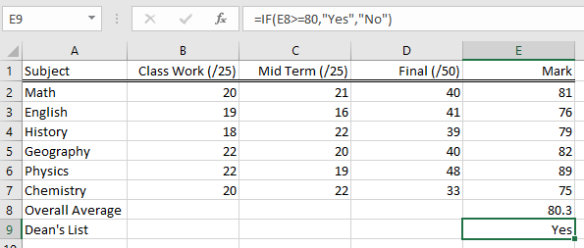

## Soccer

Select the “Soccer” sheet

* Calculate the Goal Differential (GD) equal to Goals For (GF) minus Goals Against (GA)
* Calculate the Points for each team, 3 points for a Win (W), 1 point for a Draw (D)
* Format the sheet
* Sort by Points descending

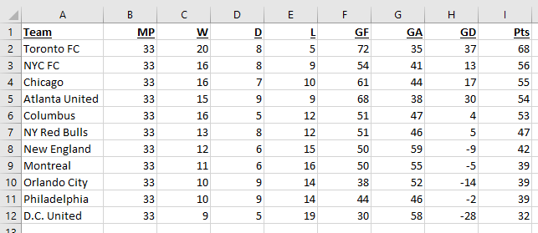

## Baseball

Select the “Baseball” sheet

* Calculate the winning percentage for each team equal to the Wins / (Wins + Losses)
* Sort each division by winning percentage
* Format appropriately

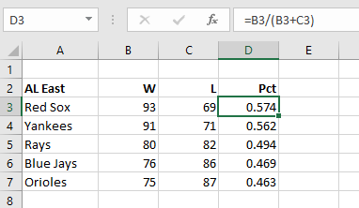

## Mileage

Select the “Mileage” sheet

* Calculate the mileage as (Current miles – old miles) / Gallons
* Format Gallons and MPG with one decimal place
* Format Odometer with no decimals but with 1000 separator
* Change the Date format to MM/DD/YY
* Format the headings

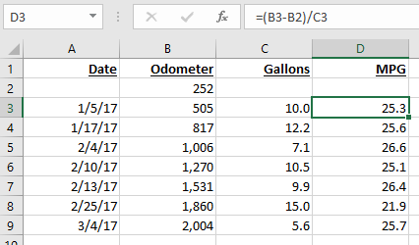

## Cake Pans

Select the “Cake Pans” sheet

Which shapes have the greatest area, i.e. will take the most batter?

* Enter a formula to calculate the area of each cake pan
  + Area of a square or rectangle = height x width
  + Area of a circle = 3.1415 x (diameter/2) x (diameter/2)
* Format the columns and headings
* Format the Area to be one decimal place
* How many cupcakes to equal one 8” round cake?

