Create a new worksheet:

* Open Windows Explorer (hint: Ctrl-E), navigate to your USB key, New -> MS Excel Worksheet
* Rename it to Practice 1.xlsx (use F2 or right click and rename)
* Double click to open it

Enter data and take a copy:

* Enter the following data (hint, use the trick to auto-fill months)

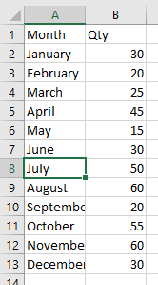

* Save a copy of the sheet, a workbook can contain may sheets
* Right click on Sheet1 at the bottom, Check Create a copy, Select (move to end), Ok
* Right click on Sheet1, Rename, “Original”, Click on Sheet1 (2)
* Save the workbook

Do a little formatting:

* Click on Qty then the align right button
* Click on the arrow to the left of column A, and above row 1 to select entire sheet  
  Double click on the divider between any two columns to auto resize
* Click on Row 1 to select entire row, Bold it
* Select A1 and B1, select little arrow beside the Border box  and select Thick Bottom Border
* Should result in

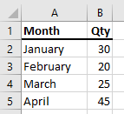

Work with ranges:

* Select the 12 Qty values, information bar at the bottom of the screen should read  
  
* Select the 12 Qty values, and click the Sum button  (right side of Home tab)  
  Should result in   
  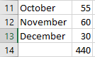
* Click on the total cell (440) and press delete to clear
* Select the 12 values again , click the down arrow beside the Sum button, click on Average
* Double click on the line to the right of the B column header to resize the column  
  Should result in  
  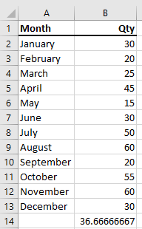
* Click on B14, Formula Bar should display  
  

Another Column:

* Select B1 down to B14, right click, Copy, click on C1, click on paste button (top left of Home tab)  
  (could also use Ctrl-C and Ctrl-V)
* Change the heading of column B to 2016, and column C to 2017
* Put a formula in Jan 2017 to make it 1000 time Jan 2016  
  
* Copy the cell for Jan 2017, select the cells for Feb 2017 to Dec 2017, Paste
* Resize all columns, should result in   
  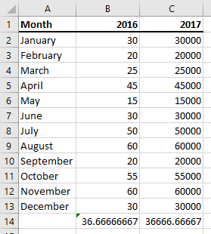

More formatting:

* Click on Column C, Right Click and Select Format Cells
* Select Category Number, Select 1 Decimal Places, Select Use 1000 Separator, Ok  
  Looks good except for the year so Undo
* Select cells C2 to C14 and repeat the formatting
* Select cell C2, click on the Format Painter button (near paste) , and paint B2 to B14
* Should result in  
  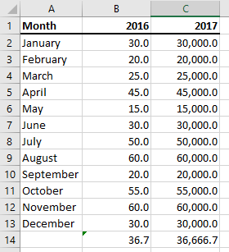

Sorting and dates:

* Select cell A1 to C13 (everything except the averages)
* Click on the Data tab followed by the Sort button
* “My data has headers” should be checked, sort by 2016, Ok
* Try sorting by Month. What happens?
* Hit undo button or Ctrl-Z to get back to sorted by Month
* Select the cell with “January”, replace with “Jan 1”. What happens?
* Replace the other Months with the first of each month
* Select the 12 cells with dates
  + Right click, Format cells
  + Select category date
  + Select \*Wednesday, March 14, 2012
  + Resize the column
* Select the data (exclude the header and average)
  + Sort by 2017
  + Sort by Month. What happens?
* Should result in  
  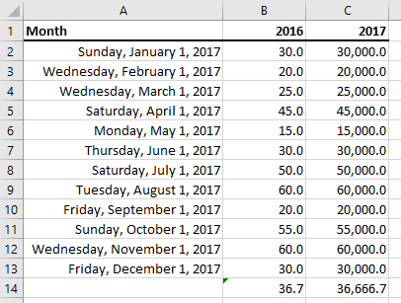

More Calcs:

* In cell A14 enter the label “Monthly Average”
* In cell A15 enter the label “Unit Price”
* In cell A16 enter the label “Avg Monthly Sales”
* In cell A17 enter the label “Tax”
* In cell A18 enter the label “Total”
* In cell B15 enter value 20
* In cell B16 enter the calculation =B14\*B15
* In cell B17 enter the calculation =B16\*0.13
* In cell B18 enter the calculation =B16+B17
* Format the cell B15 to B18 as Currency with 2 decimal places
* Copy B15 through B18 to C18
* Change the unit price for 2017 to $10
* Should result in  
  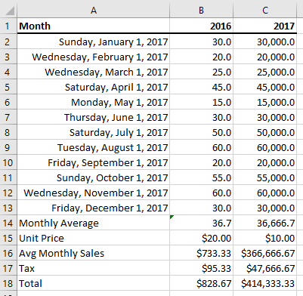

Finish up:

* Enter your name and date on the spreadsheet
* Select the whole sheet and change the font size to 14
* Select the Total row and shade light gray
* Use the Page Layout tab to change print options
  + Set page orientation to Landscape
  + Change the margins to Narrow
  + Set Gridlines to Print
* Print and hand in