Use Excel to create a timesheet to report class hours:

* Use the sum function for totals
* Should the grand total (14) be a vertical or horizontal sum?

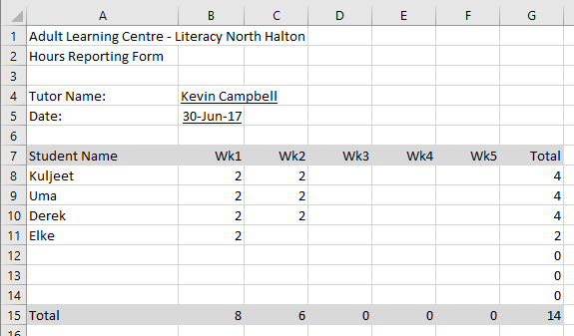

Use Excel to create a budget doc:

* Use formulas for totals and tax calculations
* Use “Bottom border” for underlining cells
* Right justify column headers
* Use “Number” or “Currency” formatting as appropriate

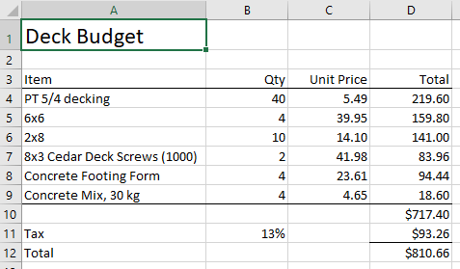

Use Excel to create a report card:

* The marks should be the sum of the class work, mid term, and final
* Overall average is the average of six marks above. Format it with one decimal place.
* For the Dean’s List insert the formula below. What does it do? Try adjusting some marks so that the overall average is more or less than 80.

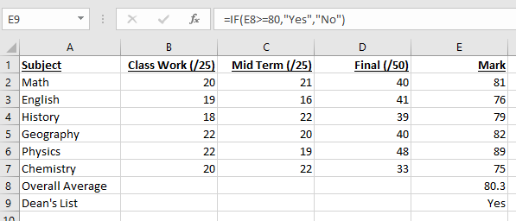

Absolute and relative references

Create the following spreadsheet. The intention is the white cells will be the product of grey cells along the top and the side.

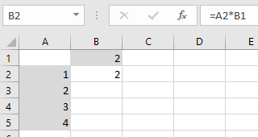

Copy cell B2 to B3 through B5. Did you get what you expected or did you get:

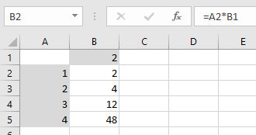

Edit the formula in cell B2 to the one listed below and copy to B3 through B5:

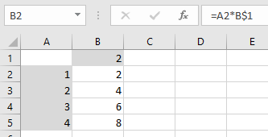

Troubleshooting

Create the following simple spreadsheet. Don’t use the sum function for the total.

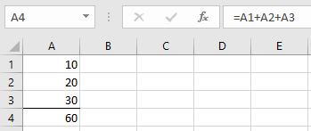

Delete the value in cell A2. What happens? How are blanks treated?

Delete row 2 entirely. What happens?

Insert a row after row 1. Enter the value 40. Is the total correct?

More formulas

Create the following spreadsheet with three numbers and their average

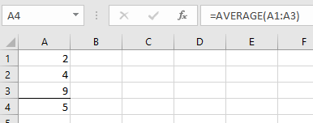

Create a second column with the value in B1 set to “=A1”, copy the value to B2 and B3.

What do you think the formula for B4 will return? Try it to confirm.

